We will now display some mathematical and algorithmic aspect of scan conversion . we will discuss ways to handle several commonly encountered primitives include line, circle,ellipse.

1 - SCAN-CONVERTING A LINE
Here , we will display 3 algorithms direct,DDA,BH

DIRECT USE OF THE LINE EQUATION
Asimple approach to scan-converting aline is to scan-convert P1 and P2 to pixel coordinates(x1,y2)
And (x2,y2) , and set m=(y2-y1) / (x2-x1).
The function of the direct-equation algo:-
void Direct(HDC hdc,int x1, int x2,int y1,int y2)
{
int dx=x2-x1;
int x,y,xend;
int dy=y2-y1;
int m=dy/dx;
int b=y1 - (m*x1);
if(dx<0)
{
x=x2;
y=y2,xend=x1;
}
else if(dx>=0)
{
x=x1;
y=y1,xend=x2;
}

while(x< xend)
{
SetPixel(hdc,x,y,RGB(0,0,250));
x++;
y=(m*x)+b;
}
}
The output of this algorithm:-
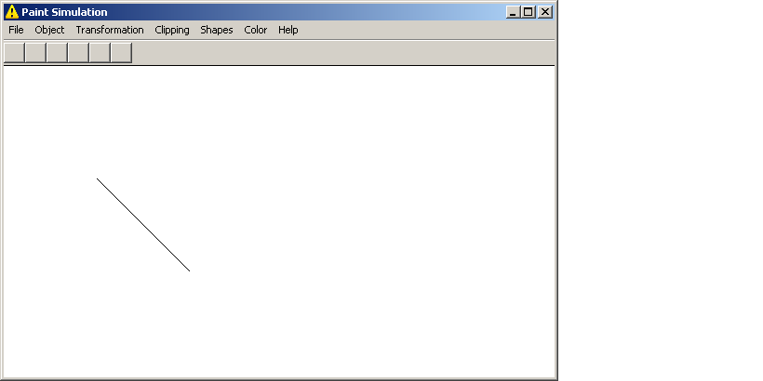

DDA ALGORITHM

Dda algorithm is an incremental scan-conversion algorithm . this method is characterized by performing calculations at each step using result from preceding step.

Yi+1=yi + m* (xi+1 - xi).

Xi+1=Xi +(1/ m* (Yi+1 - Yi)).

The function of the DDA algo:-
void DDA(HDC hdc,int x1,int x2, int y1, int y2 , COLORREF col)
{
float dx=x2-x1;
float dy=y2-y1;
float m=dy/dx;
int x,y,xend,yend;
if(m<=1)
{
x=x1;
yend=y1;
while(x<x2)
{
y=(int)(yend+0.5);
SetPixel(hdc,x,y,col);
x++;
yend=yend+m;
}
}
else if(m>1)
{
y=y1;
xend=x1;
while(y<y2)
{
x=(int)(xend+0.5);
SetPixel(hdc,x,y,col);
y++;
xend=xend+(1/m);
}
}
}

The Output of the execution of the algorithm:-
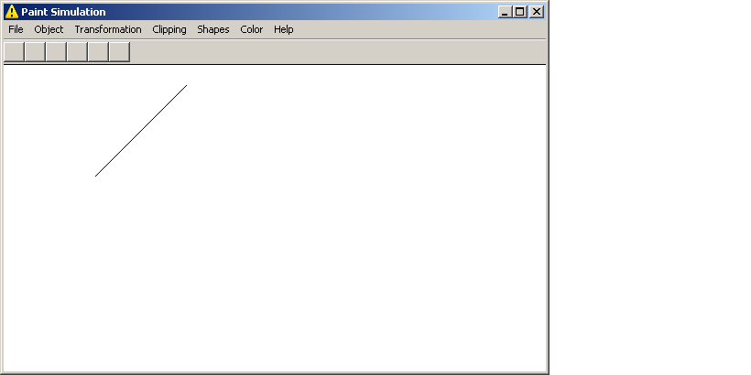

Bresenham’s Line algorithm

This an efficient incremental algorithm for scan-converting lines. It produce an accurate results using only integer addition,subtraction,…
It depend on two point and test either of them is closer to the current point and tack it as next point .
The function of the BH algo:-
void BH(HDC hdc, int x1,int x2,int y1,int y2)
{
int dx=x2-x1;
int dy=y2-y1;
int d=2*dy-dx;
int x=x1,y=y1;
SetPixel(hdc,x1,y1,RGB(250,0,0));
while(x<x2)
{
x++;
if(d<0)

d=d+(2*dy);

else
{
y++;
d=d+(2*(dy-dx));

}
SetPixel(hdc,x,y,RGB(250,0,0));
}
}
The out put of BH algorithm :-
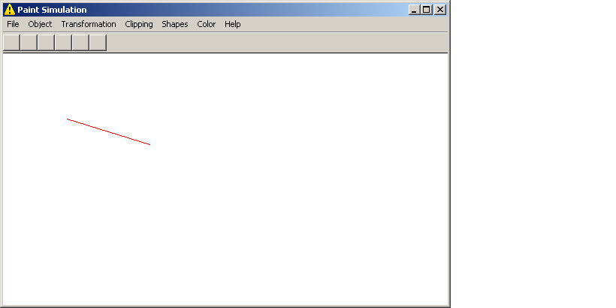

2 - SCAN-CONVERTING A CIRCLE

Circle is asymmetry figure, it depend on 8 point to be drawn . here we will display 4 algorithm fo scan – converting circle.

Polynomial Algorithm
with this method , each x coordinate in the sector, from 90 ◦ to 45 ◦ , is found by stepping x from 0 to r/sqrt(2) , and each y is calculated by sqrt(r*r – x*x).
The function of the polynomial _circle algo:-
void Cart(HDC hdc, int cx,int cy, int r,COLORREF col)
{
int x=0;
int xend=(r/sqrt(2));
int y;
while(x<xend)
{
y=sqrt((r*r) - (x*x));
SetPixel(hdc,x+cx,y+cy,col);
SetPixel(hdc,y+cy,x+cx,col);
SetPixel(hdc,-y+cy,x+cx,col);
SetPixel(hdc,-x+cx,y+cy,col);
SetPixel(hdc,-x+cx,-y+cy,col);
SetPixel(hdc,x+cx,-y+cy,col);
SetPixel(hdc,y+cy,-x+cx,col);
SetPixel(hdc,-y+cy,-x+cx,col);
x++;
}
}
The out put of the algorithm:-
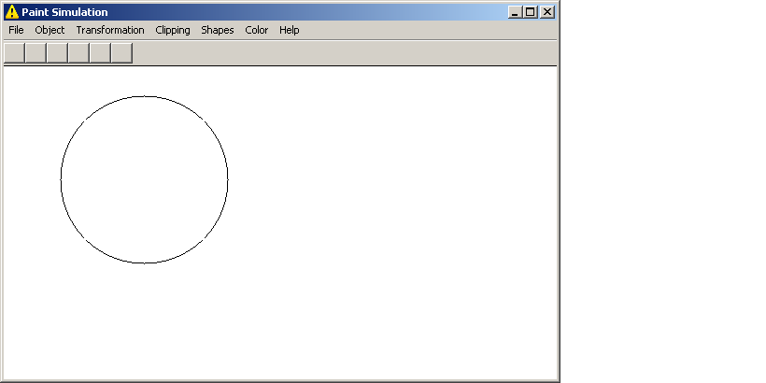

TRIGONOMETRIC ALGORITHM

HERE , definig circle depend on the trigonometric function

X= r cosΘ ,

Y= r sinΘ .
By , this meyhod Θ stepps from 0 to Л / 4.
The function of the polynomial _circle algo:-
void Trig(HDC hdc,int cx,int cy,int r,COLORREF col)
{
double Theta=0;
while(Theta<=22.0/28)
{
int x=(int)(r*cos(Theta));
int y=(int)(r*sin(Theta));
SetPixel(hdc,x+cx,y+cy,col);
SetPixel(hdc,y+cy,x+cx,col);
SetPixel(hdc,-y+cy,x+cx,col);
SetPixel(hdc,-x+cx,y+cy,col);
SetPixel(hdc,-x+cx,-y+cy,col);
SetPixel(hdc,x+cx,-y+cy,col);
SetPixel(hdc,y+cy,-x+cx,col);
SetPixel(hdc,-y+cy,-x+cx,col);
Theta=Theta+(7.0/(2*22.0*r));
}
}
The output of this algorihm:-
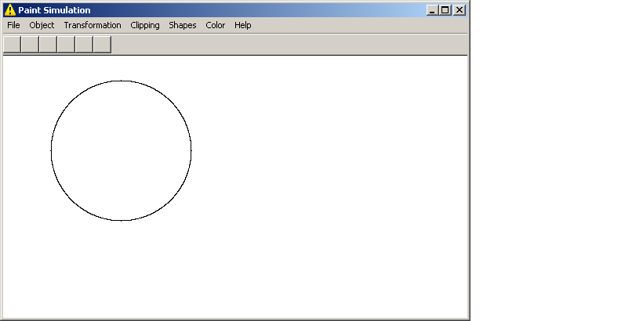

Bresenham’s Circle algorithm

Through this method we using the integer values to calculate the operation of multiplication , addition,…
The function of the BH _circle algo:-
void BH_CIRCLE(HDC hdc,int cx,int cy,int r,COLORREF col)
{
int x=0,y=r,d=3-2*r;
while(x<=y)
{
SetPixel(hdc,x+cx,y+cy,col);
SetPixel(hdc,y+cy,x+cx,col);
SetPixel(hdc,-y+cy,x+cx,col);
SetPixel(hdc,-x+cx,y+cy,col);
SetPixel(hdc,-x+cx,-y+cy,col);
SetPixel(hdc,x+cx,-y+cy,col);
SetPixel(hdc,y+cy,-x+cx,col);
SetPixel(hdc,-y+cy,-x+cx,col);
if(d<0)
d=d+4*x+6;
else
{
d=d+4*(x-y)+10;
y--;
}
x++;
}
}
The out put of this algorithm:-
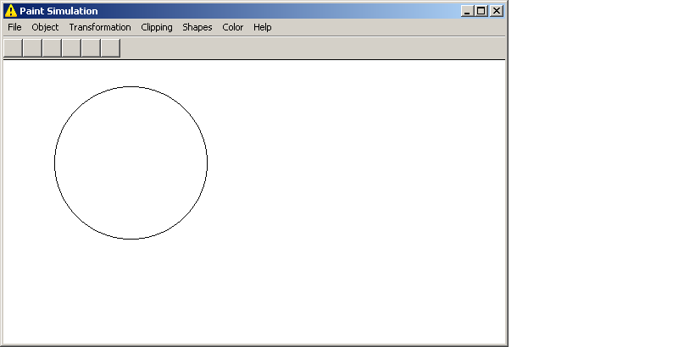

MID POINT CIRCLE ALGORITHM

THIS ALGORITHM ALSO DEPEND ON INCREMENTAL METHOD

IT depend on the following relation.
(X^2+Y^2 – R^2) < , > , =
The function of the MIDPOINT _circle algo:-
void MidPoint(HDC hdc,int cx,int cy,int r,COLORREF col)
{
int d=1-r;
int x=0,y=r;
SetPixel(hdc,cx,cy,col);
while(x<=y)
{
// SetPixel(hdc,x,y,col);
if(d<0)
d=d+2*x+3;
else
{
d=d+2*(x-y)+5;
y--;
}
x++;
SetPixel(hdc,x+cx,y+cy,col);
SetPixel(hdc,y+cy,x+cx,col);
SetPixel(hdc,-y+cy,x+cx,col);
SetPixel(hdc,-x+cx,y+cy,col);
SetPixel(hdc,-x+cx,-y+cy,col);
SetPixel(hdc,x+cx,-y+cy,col);
SetPixel(hdc,y+cy,-x+cx,col);
SetPixel(hdc,-y+cy,-x+cx,col);
}
}
The out put of this algorithm:-
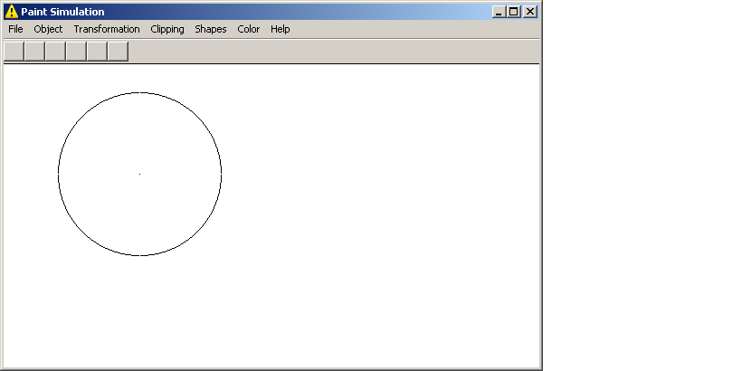

2 - SCAN-CONVERTING AN ELLIPSE

The ellipse like circle shows the symmetry . but in the case of the ellipse , symmetry depend on 4 point.

Here we use polynomial , trigonometric, midpoint algorithms.

Polynomial algorithm

The polynomial algorithm based on the following expression
(x – h)^2 / a^2 + (y– k)^2 / b^2 = 1, in which , x is incremented from h to a .

The function of the polynomail _circle algo:-

void polynomial_ellipse( double a,double b,COLORREF color,HDC hdc )
{
int h=570,k=150; // ellipse center
double x=0.0,X_end=a; // a major axis,,, b mainor axis
while(x<=X_end)
{
double y=b*( sqrt( 1- (x*x)/(a*a) ) );
plot_fourPoints(x,y,h,k,color,hdc); // function to drow four points

x+=.001;
}//end loop
}

The out put of this algoritm:-
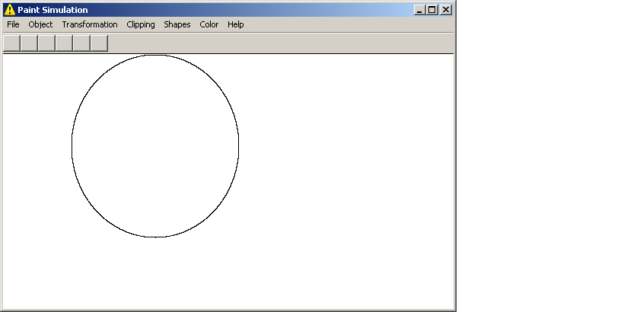

Trigonometric algorithm
this algorithm uses the following trigonometric relationships.

X= a cosΘ+h ,

Y= b sinΘ +k.

By , this meyhod Θ stepps from 0 to Л / 2.

The function of the trigonometric_circle algo:-

void Parametric(HDC hdc, int a,int b,int h,int k,COLORREF col)
{
double theta=0;
int x,y;
double theta_end=44/7;
while(theta<theta_end)
{
x=(int)(a*cos(theta));
y=(int)(b*sin(theta));
SetPixel(hdc,x+h,y+k,col);
SetPixel(hdc,-x+h,-y+k,col);
SetPixel(hdc,-x+h,y+k,col);
SetPixel(hdc,x+h,-y+k,col);
theta+=0.05;
}
}
The output of this algorithm:-
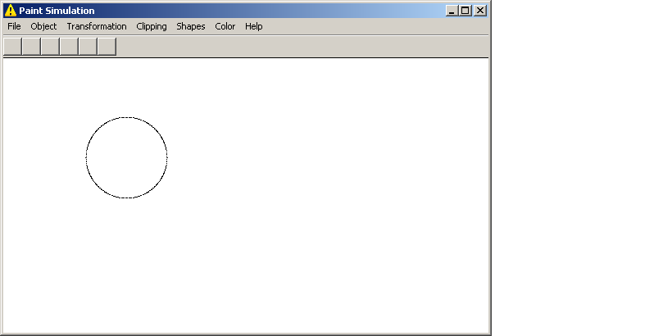

MID POINT ELLIPSE ALGORITHM

THIS AN INCREMENTAL METHOD FOR SCAN_CONVERTING AN ELLIPSE THAT IS CENTERD AT THE ORIGIN .

It is like mid point circle algorithm ,but with 4 points.

The function of the midpoint_circle algo:-

void MidPoint_ellipse(HDC hdc, int a, int b, COLORREF col)
{
int x = 0;
int y = b;
int aa = a*a;
int bb = b*b;
int aa2= aa*2;
int bb2= bb*2;
int h=570,k=150;
int fx=0;
int fy=aa2*b;

int p = int (bb - aa*b + 0.25*aa) ;

while(fx < fy)
{
plot_fourPoints(x, y , h, k,col, hdc);

fx=fx+bb2;

if(p<0)
p = p + fx + bb;
else
{
fy = fy - aa2;

p = p + fx + bb - fy;
y--;
}
x++;
}

p = int (bb*(x+0.5)*(x+0.5)+aa*(y-1)*(y-1)-aa*bb);

while(y>=0)
{

SetPixel(hdc, x+h , y+k , col);

SetPixel(hdc, -x+h , y+k , col);

SetPixel(hdc, -x+h , -y+k , col);

SetPixel(hdc, x+h , -y+k , col);

fy = fy - aa2;

if(p>=0)
p = p - fy + aa;
else
{
fx = fx + bb2;

p = p + fx + aa - fy;
x++;
}
y--;
}
}

The out put of this algorithm :-
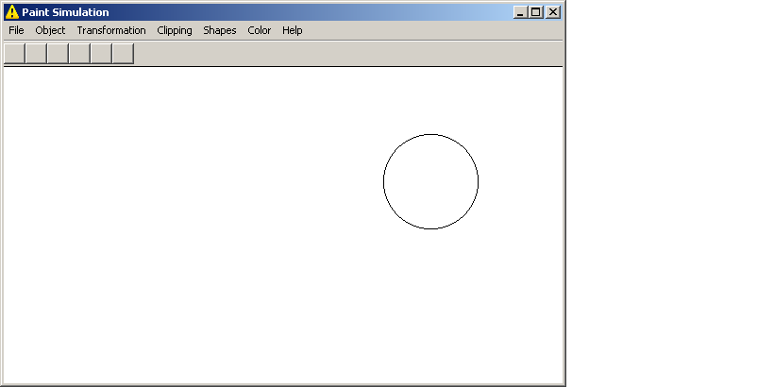

TWO DIMENSIONAL : ROTATION
Here, the object rotate Θ about the origin . the direction of rotation is counterclockwise if Θ is positive angle and clock wise if Θ is negative.

P*=R Θ(P)

X*=x cos(Θ) – y sin(Θ) and y*=x sin(Θ) + y cos(Θ), look at fig 1,2,3

The function of rotation :-

matrix rotation(double theta)
{
matrix mat=identity();
mat(0,0)=(double)cos(theta);
mat(0,1)=-(double)sin(theta);
mat(1,0)=-mat(0,1);
mat(1,1)=mat(0,0);
return mat;
}
The out put:-
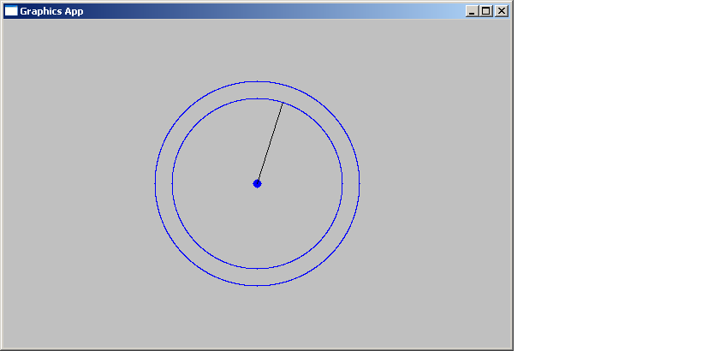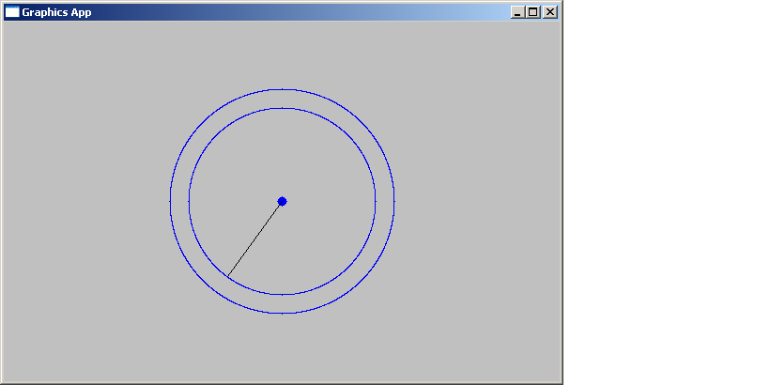
Fig(1) fig(2)

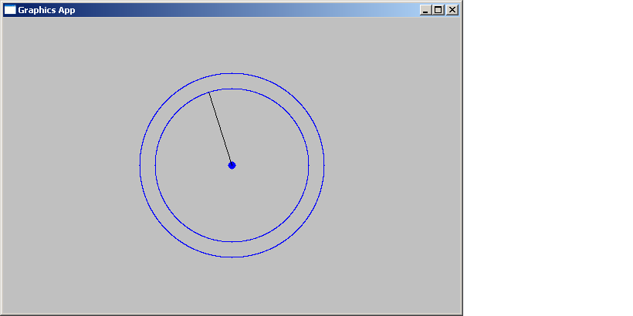fig(3)

TWO DIMENSIONAL : SCALAR

It is the process of expand the dimension of object .

The function of scalaing: look at fig(1) & fig(2)
matrix scalar(int sx,int sy)
{
matrix mat=identity();
mat(0,0)=sx;)
mat(1,1)=sy;
return mat;
}

The output of this algorithm:
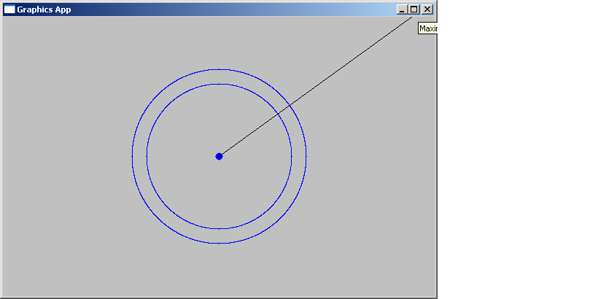

Fig(1) fig(2)

TWO DIMENSIONAL : Traslation
an object is displaced a given distance and direction from its original position . p׳ =T(p) where x = x + tx and yَ = y+ty, look at fig (1),fig(2)
the function of translation:-

matrix translation(int tx,int ty)
{
matrix mat=identity();
mat(0,2)=tx;
mat(1,2)=ty;
return mat;
}

The output of this algorithm:-
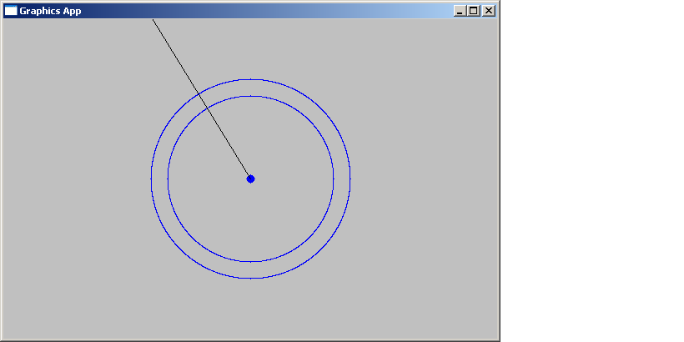

Fig(1) fig(2)

TWO DIMENSIONAL : REFLECTION
If either the x or y treated as a mirror , the object has a mirror image or refelction .the mirror reflection about x axis is given by . p׳ =M(p)
Where x׳= x and y׳= - y, vice versa to y axis

The function of the refelction to x axis:- look at fig(1) and fig(2)
matrix Refelsction_X()
{
matrix mat=identity();
mat(0,0)=1;
mat(1,1)=-1;
return mat;
}

The function of the refelction to Y axis:- look at fig(1) and fig(3)

matrix Refelsction_Y()
{
matrix mat=identity();
mat(0,0)=-1;
mat(1,1)=1;
return mat;
}

The out put of this algorithms:
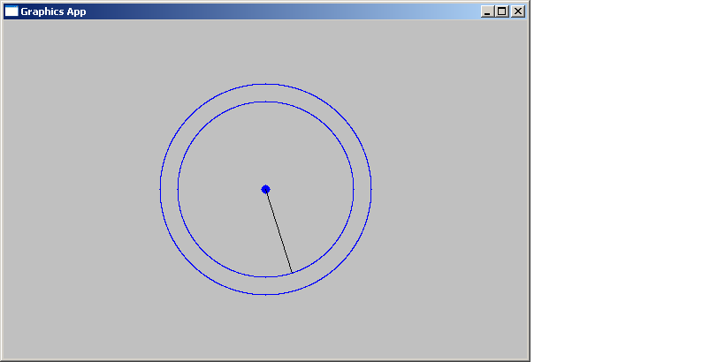
Fig(1) fig(2)
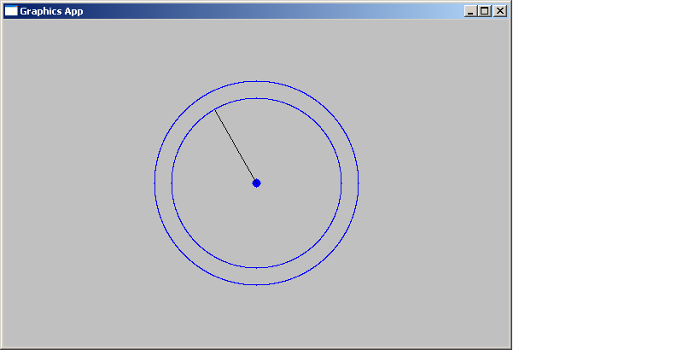

Fig(3)

REPORT ON THE GRAPHICS ALGORITHMS

Wael hassan helmi
Sec (6)
3rd year , faculty of computers and
information science
supervisior/ prof. Adel Abo almagd

